My Family Health Portrait
Draft Content for Open/Save/Print Screens and Submodals

Table of Contents
OPEN SAVED HISTORY 1
SAVE HISTORY FILE 1
VIEW HISTORY REPORT 1
CHANGE REPORT OPTIONS 1

OPEN SAVED HISTORY
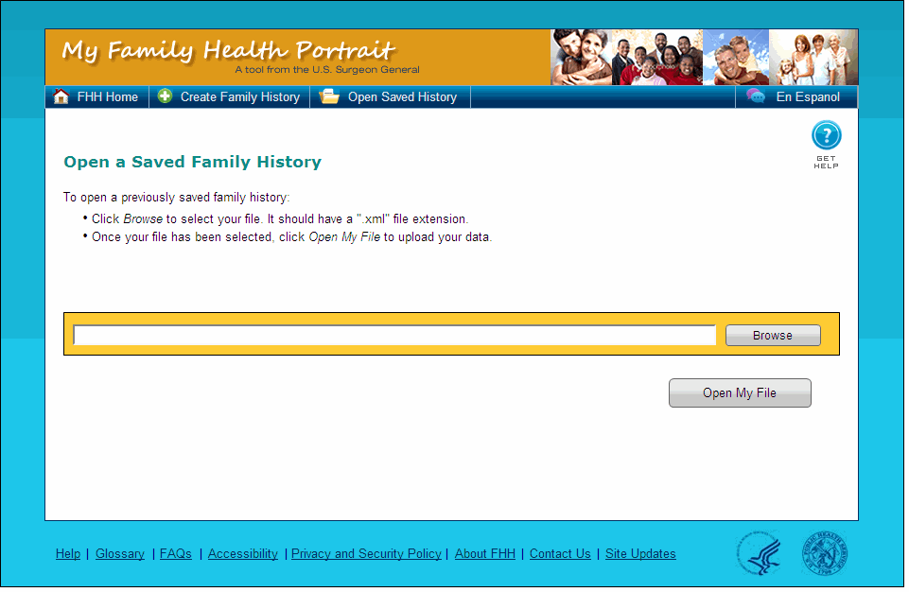
Open a Saved Family History
To open a previously saved family history:
• Click Browse to select your file. It should have an ".xml" file extension.
• Once your file has been selected, click Open My File to upload your data.

SAVE HISTORY FILE
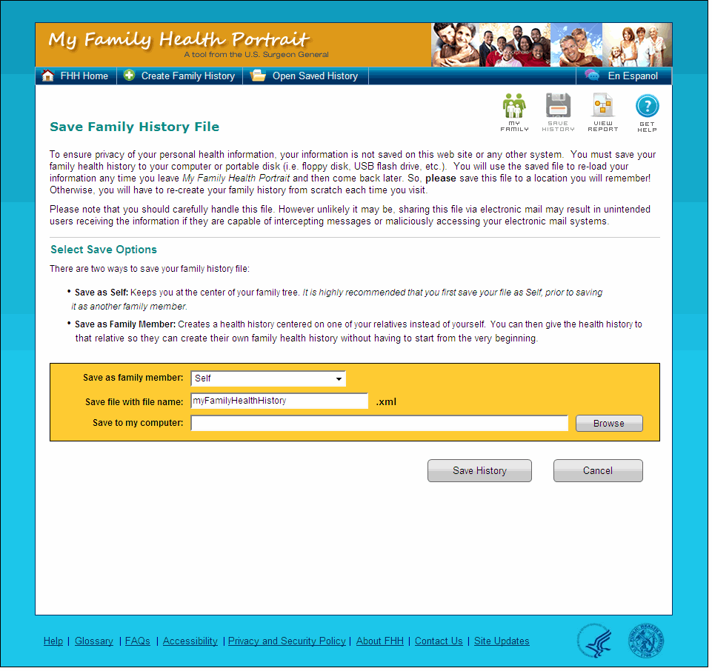
Save Family History File
<Can we put the following content into a ‘Tips’ box or other such call-out around or when the ‘BROWSE’ button is selected?>
Please remember where you save the file. If you do not remember where the file is, you will need to enter in your family history again later!
Select Save Options
You are about to save your family health history to your computer or portable disk (i.e. floppy disk, USB flash drive, etc.). There are two ways to save your family history file:
Save as Self: Keeps you at the center of your family tree. It is highly recommended that you first save your file as Self, prior to saving it as another family member.
Save as Family Member: Creates a health history as though you were the family member chosen. You can give the file to that family member so they do not start from the beginning.
<THIS CONTENT WILL APPEAR BELOW THE ‘SELECT SAVE OPTIONS’ SECTION>
Please note that you should provide this file only to people you trust. Only send the file via e-mail if you trust the security of your e-mail provider.

VIEW HISTORY REPORT
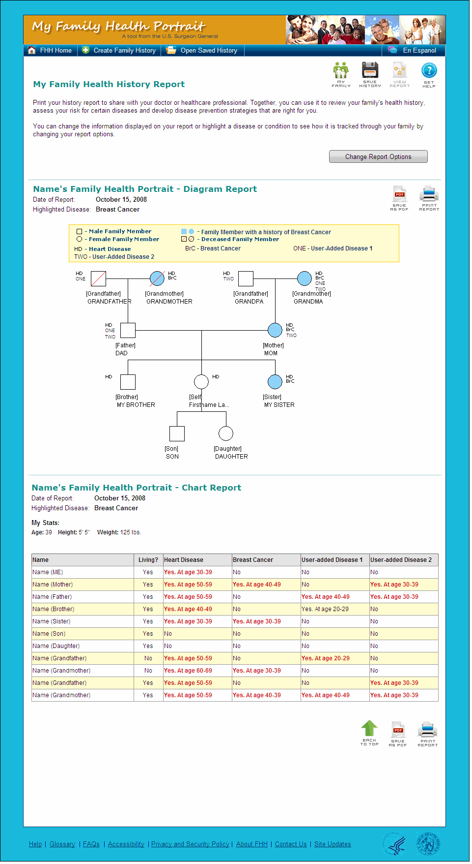
My Family Health History Report
Review your family health information below. You can print it out by clicking on the ‘Print Report’ button. Share it with your health care worker and talk to them about how to stay healthy!
Click the ‘Change Report Options’ button to choose a disease or condition and see the family members that have that disease.

CHANGE REPORT OPTIONS
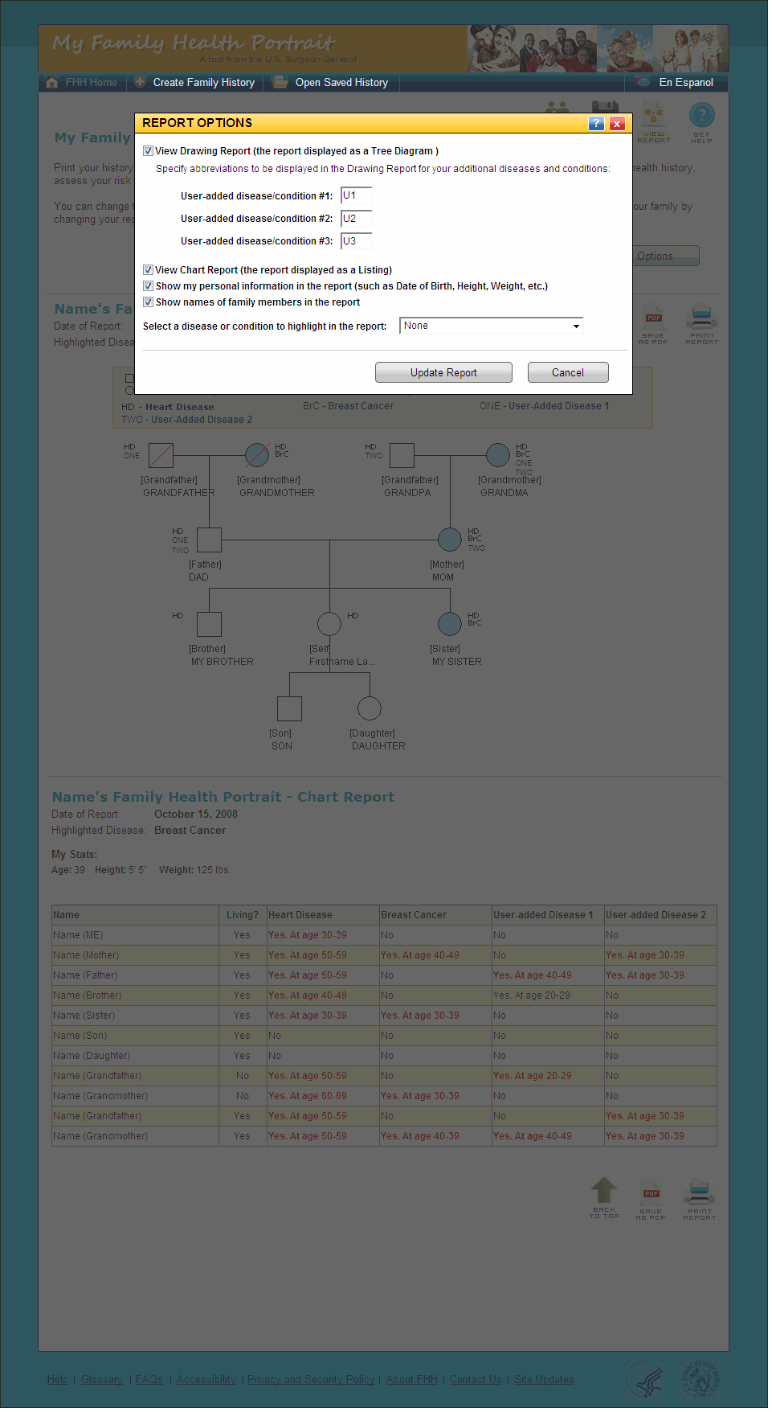

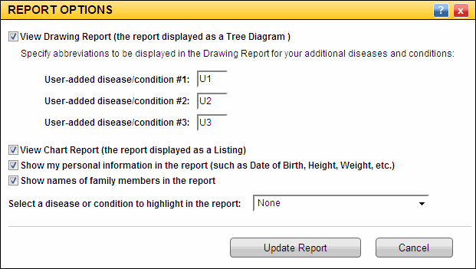

Select a disease or condition to highlight in the report:
__ Show names of family members in the report
__ Show my personal information in the report (such as Date of Birth, Height, Weight, etc.)
__ View Chart Report (the report displayed as a Listing)
__ View Drawing Report (the report displayed as a Tree Diagram )
Specify abbreviations to be displayed in the Drawing Report for your additional diseases and conditions:
User-added disease/condition #1:
User-added disease/condition #2:
User-added disease/condition #3:

